EASE
NcNciInquiry
Guideline
(External App Data)

Page 1

The information contained herein is confidential and proprietary and should not be disclosed to unauthorized persons. It is meant for use by authorized representatives of Brightspeed.

Table of Contents

Steps for Accessing .............................................................................................................................. 3
Background .................................................................................................................................. 3
Access .......................................................................................................................................... 3
Network Channel / Network Channel Interface Inquiry ............................................................. 4
NC Code........................................................................................................................................ 4
NCI Code ...................................................................................................................................... 4
SECNCI Code............................................................................................................................... 4
ASR Type Code ............................................................................................................................ 5
Company………………………………………………………………………………………… 5
System Navigation ........................................................................................................................ 5

Steps for Accessing

Background | External App Data provides a method to validate key information to enter accurate information for an Access Service Request (ASR) within VFO. This is a connection from within EASE VFO to the external Reference Table Maintenance Utility.  Examples: NC/NCI codes.

Continued on next page

Steps for Accessing, Continued

External App  Data /  NcNciInquiry | To validate Brightspeed specific NC/NCI codes – follow directions listed below.  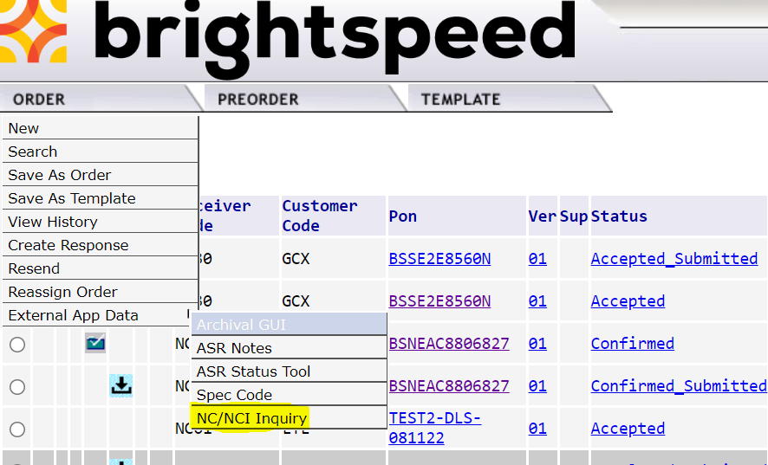  The NcNciInquiry can be accessed by hovering the External App Data menu item from the ORDER drop down menu, and then selecting NcNciInquiry.
NC Code | NC CD: Identifies NC code  Enter the NC code to execute search on.  - Valid entries: full NC code, partial CLLI code with wild card search character of ‘%”  - ex: HCE- or HCE%  - System will display list of valid NC codes with associated NCI CD, SEC NCI CD and ASR Type for entry into VFO order.
NCI Code | NCI CD: Identifies NCI code  Enter the NCI code to execute search on.  - Valid entries: full NCI code, partial CLLI code with wild card search character of ‘%”  - ex: 01FCF.X or 01FCF.%  - System will display list of valid NCI codes with associated NC CD, SEC NCI CD and ASR Type for entry into VFO order.
SECNCI Code | SEC NCI CD: Identifies secondary NCI code.  Enter the NCI and SEC NCI code to execute search on.  - Valid entries: SEC NCI codes  - For best results enter NC/NCI/SEC NCI fields.  - System will display list of valid NC/NCI/SEC NCII codes with associated criteria entered.
ASR Type Code | ASR Type CD: Identifies associated ASR Reqtype for NC/NCI code.  Enter the ASR Type code to execute search on.  - Valid entries: ASR Reqtype code  - ex: Reqtype SD  - System will display list of valid ASR Types for associated NC CD, NCI CD and SEC NCI CD for entry into VFO order.
Company | Company: Identifies associated NC/NCI/SECNCI Company.  Enter the Company name to execute the search on.  • Valid entries: Brightspeed.
System  Navigation | To return to the Network Channel / Network Channel Interface, select Home. To return to EASE VFO close the browser window used for the Reference Table Maintenance Utility.

